Staying Well Referral Form – easy read
Phone number: 0800 023 6475

To be completed and returned to:
- Brighton: stayingwell.brighton@southdown.org
- Eastbourne: stayingwell.eastbourne@southdown.org
- Hastings: stayingwell.hastings@southdown.org

The Staying Well service offers support to individuals that feel they are no longer able to cope. Please use this form to refer someone for early crisis intervention.

To make a referral to Staying Well please complete and return the form below:
Date of Referral

_________________________________________

Referrer
Name of Referrer

_________________________________________
 | Profession and organisation
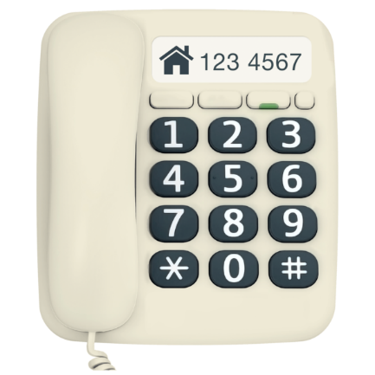 | Email  Telephone Number

Patient/Client details
Name

_________________________________________
Gender

Male Female

Other (please state)

__________________________________________
Date of Birth
Address
Email

Telephone Number

Next of Kin / Emergency Contact Number
Do they have a carer ☐ or are they a carer themselves ☐ ?

Carers name:

Other professionals
GP name and surgery (if referral from other professional):

Psychiatrist details/ other mental health professional(s) involved:

Reason for the referral
Please describe the reason for the referral (the current situation, any relevant background information, presenting difficulties, risks and your recommendation):

Where would you have usually referred your patient/ client if Staying Well had not been available?

Primary Care / GP ☐ Haven, MHRRS, Lighthouse ☐ Wellbeing & Secondary Care ☐ Ambulance (SECAMB) ☐ ASC ☐ A&E ☐ Crisis Team ☐ Police ☐ Other ☐

Does the patient/ client have any communication needs or restrictions?

Does the patient/ client want family, friends or carers involved in their care and support? Please give details:

Has the client consented to family, friends or carers being involved?

Does the patient/ client need additional support to help them access services?

(We are able to provide maps on request showing transport links to help patients/ clients find the Staying Well service in Brighton.)

Please email completed forms to:

- Brighton: stayingwell.brighton@southdown.org
- Eastbourne: stayingwell.eastbourne@southdown.org
- Hastings: stayingwell.hastings@southdown.org

